Seminar on Holy Bible and Year of the Family
For all the Lay Associate groups of Vijayawada Province
Two seminars were conducted this year at Nirmala Evangelization center, Tanuku for all the Lay Associates of the Vijayawada province to reflect on the Year of the Family choosing the theme, Holy Bible and Family. The first seminar was held at the end of August and the second seminar on 29th October 2017. These seminars focused on how to live the Word of God effectively to inspire others, giving good example, especially giving witness to the Gospel values as Christian families. Reflections and guidelines were drawn from the Bible on family life, how to bring up children in the fear of God, how to build the house of God and to build one’s own house.
After the seminar, one of the Lay Associates shared her experience as follows.
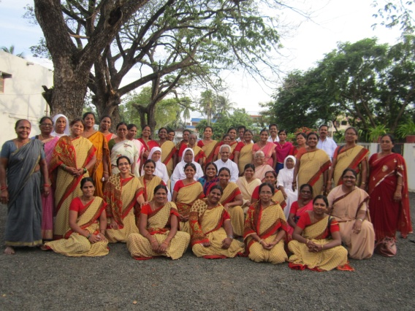
I realized that I have a lot of talents buried deep within me which I need to utilize for the greater glory of God. Eph 1:4 touched me that God called me even before the foundation of the world to be holy and blameless. I think this seminar is arranged just for me. I learned what my responsibility towards my family that is duty towards children, husband and in-laws. Eph. 5:16 very strongly speaks to me there is no time to waste, ”I must preach the Gospel in season and out of season, seizing every possible chance.” I was always getting irritated with children. Today I learned how to take care of them in love and through prayer. My soul is strengthened through the Word of God. I would have missed a lot of blessings; you dug around the tree of our soul and nurtured with the manure of the Word of God. I was so weak with my family burdens when I came here; but I am strengthened and learned how to find happiness in my family life.
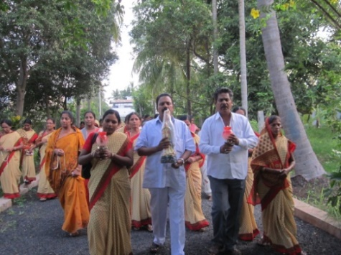
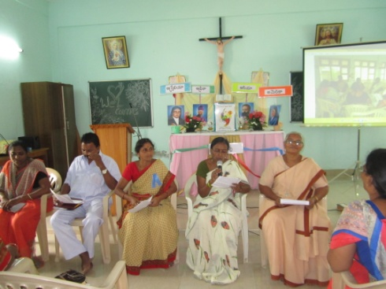

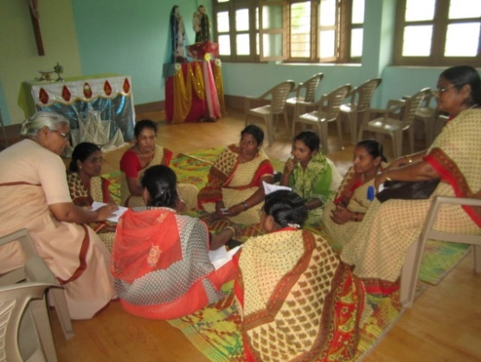
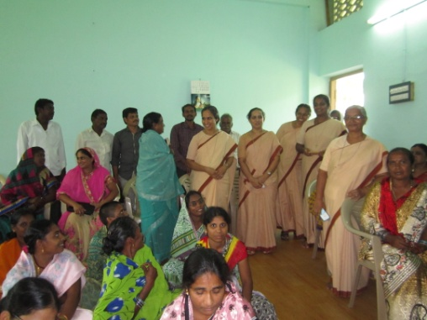

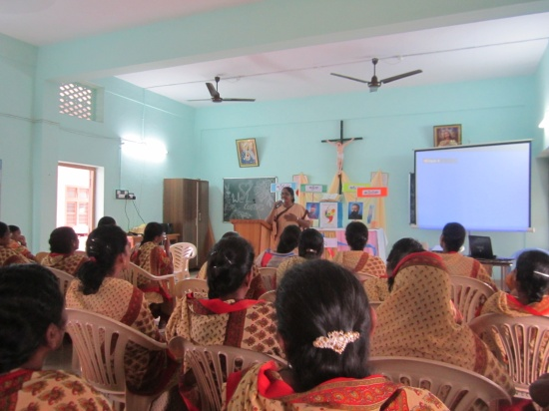
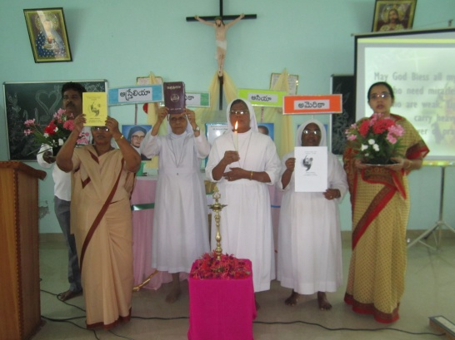

The participants were in renewed in mind and Spirit to live a meaningful family life and to be committed to spiritual and moral values in their daily life.
---------------------------------------------------------------------------------------------------------------------

Reflection on the Year of Family, Lay Associates of MSI, Nirmala Convent Vijayawada

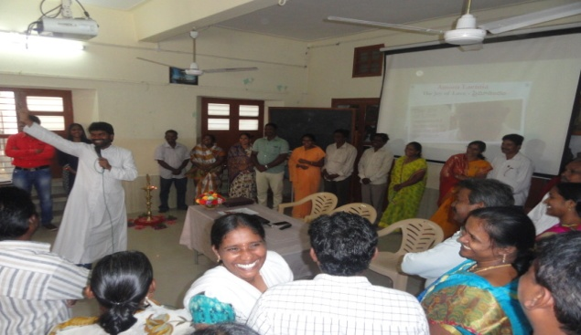
To deepen the reflection on the Year of the family on 2nd September 2017, a reflection on Family life was organized for the families of the Lay Associates. The catholic families of teachers and co-workers (school and convent) too joined. The meeting began at 9 a.m. with the lighting of the traditional lamp.

Sr. Gladis, in her introductory talk, spoke about the bond of love and unity in the family and how we are interconnected and interdependent in mutual giving and receiving.
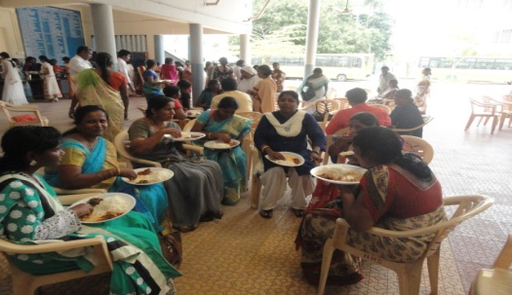
The resource person of the day, Rev. Fr. K. Mariadas, the Director of SAMVRUDDHI COUNSELLING AND PSYCHOLOGICAL SERVICES, Gunadala, began by an ice-breaking session inviting all the couples on to the stage. He with his spontaneity removed all the inhibitions and shyness of the participants, and helped them to speak about their family life.

From 10 am to 12.30 pm we had input sessions by him based on POST- SYNODAL APOSTOLIC EXHORTATION AMORIS LAETITIA. He explained to us in brief each chapter with the lived examples from day today family life. He made his sessions interesting through the Power Point presentation. He also clarified many of their doubts, specially how to understand and take care of children in this modern world and brings them up in catholic faith.

It was a wonderful experience being together, listen to the joyful and sorrowful experiences of different families, which has not only enriched but created a new perspective towards the challenges of life. Paying together for various needs of the families, church and the world brought us close to each other and to feel the power of God in our lives. We are grateful to God for this opportunity, to all the sisters who have taken the trouble to organize this reflection.

